Circle Language Spec: Inheritance

System Command Shadowing
Shadowing a system command can only be displayed by opening up the system interface:

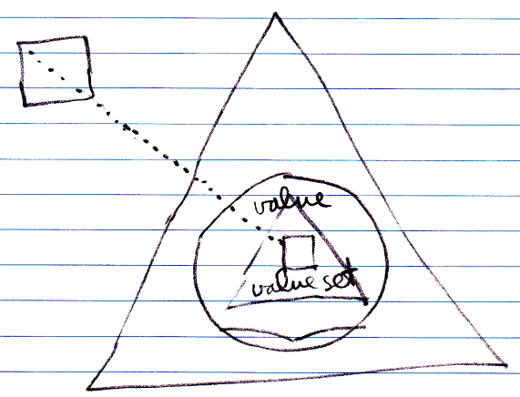

Author & Copyright: Jan-Joost van Zon Date: May 19, 2010 – July 17, 2010 Location: Oosterhout, The Netherlands Status: Finished

